**Course Methods Test 1 Year 12**

Student name: ________________ Teacher name: ________________

**Task type: Response**

**Reading time for this test : 5 mins**

**Working time allowed for this task: 40 mins**

**Number of questions: _____8______**

**Materials required:** No Cals allowed at all!

Standard items: Pens (blue/black preferred), pencils (including coloured), sharpener, correction fluid/tape, eraser, ruler, highlighters

Special items: Drawing instruments, templates, notes on one unfolded sheet of   
A4 paper, and up to three calculators approved for use in the WACE examinations

**Marks available: 40 marks**

**Task weighting: 13%**

**Formula sheet provided: no**

**Note: All part questions worth more than 2 marks require working to obtain full marks.**

Q1 (2 & 3 = 5 marks)

Determine the equation of the tangent to the following curves at the sated point:

1.  at the point 

|  |
| --- |
| **Solution** |
|  |
| **Specific behaviours** |
| 🗸 determines gradient  🗸 solves for constant of tangent |

1.  at the point 

|  |
| --- |
| **Solution** |
|  |
| **Specific behaviours** |
| 🗸 differentiates correctly  🗸 solves for gradient  🗸 solves for constant |

Q2 (3 & 3 = 6 marks)

Determine the derivatives of the following using the quotient rule and simplify your answer.

1. 

|  |
| --- |
| **Solution** |
|  |
| **Specific behaviours** |
| 🗸 correct numerator of quotient rule  🗸 correct denominator  🗸 simplified to above with factors of 2 taken out |

1. 

|  |
| --- |
| **Solution** |
|  |
| **Specific behaviours** |
| 🗸 uses quotient rule correctly  🗸 expands and adds like terms in numerator  🗸 simplifies as shown in last line above (-ve may be inside brackets) |

Q3 ( 5 marks)

Determine the coordinates of the stationary points of  using calculus and justify their nature.

|  |
| --- |
| **Solution** |
|  |
| **Specific behaviours** |
| 🗸 differentiates function  🗸 equates to zero and solves for x values  🗸 gives both coordinates for each stationary point  🗸 uses sign derivative test with actual values stated  🗸states nature of each point |

Q4 ( 1, 2 & 3 = 6 marks)

Consider an object initially at the origin that moves only in a straight line with displacement from origin, , given by  at time, seconds.

Determine:

1. Acceleration at  second.

|  |
| --- |
| **Solution** |
|  |
| **Specific behaviours** |
| 🗸 states value (no need for units) |

1. The times the object is at rest.

|  |
| --- |
| **Solution** |
|  |
| **Specific behaviours** |
| 🗸 equates velocity to zero  🗸 states times (no need for units) |

1. The distance travelled in the first 3 seconds.

|  |
| --- |
| **Solution** |
|  |
| **Specific behaviours** |
| 🗸 solves for x at t=1  🗸 solves for x at t=2&3  🗸 states distance as one term |

Q5 (2, 2 & 2 = 6 marks)

The graphs of  and  are displayed below.

|  |  |
| --- | --- |
|  |  |

1. Determine the derivative of at .

|  |
| --- |
| **Solution** |
|  |
| **Specific behaviours** |
| 🗸 uses product rule  🗸 states value |

1. Determine the derivative of  at .

|  |
| --- |
| **Solution** |
|  |
| **Specific behaviours** |
| 🗸 uses quotient rule  🗸 states value (accept -6/16) |

1. Determine the derivative of  at 

|  |
| --- |
| **Solution** |
|  |
| **Specific behaviours** |
| 🗸 uses chain rule  🗸 states value |

Q6 (3 marks)

If  use differentiation to determine the approximate percentage change in  when  increases by 3%.

|  |
| --- |
| **Solution** |
|  |
| **Specific behaviours** |
| 🗸 uses small change formula correctly  🗸 derives an expression for % change of q  🗸 states value as negative or decrease |

Q7 (5 marks)

Consider the function  as graphed below. On the axes below sketch the function  and on this graph label and show the coordinates and nature of all important features of .

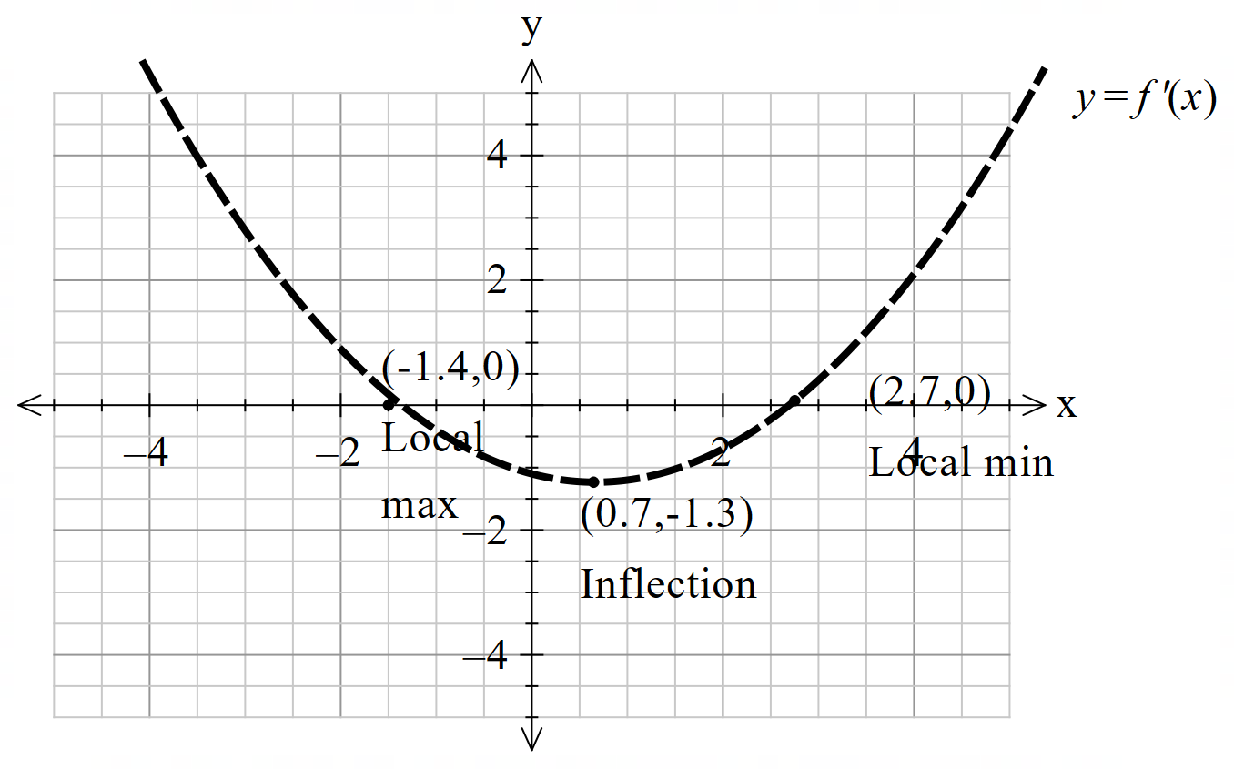

|  |
| --- |
| **Solution** |
|  |
| **Specific behaviours** |
| 🗸 shape being all concave up  🗸 All 3 points given as approx. cords (allow variance for y coord of inflection)  🗸 local min labelled on derivative graph correctly  🗸 local max labelled on derivative graph correctly  🗸inflection labelled on derivative graph correctly |

Q8 (4 marks)

A rectangle has one vertex at the origin, another on the positive x-axis, another on the positive y-axis and a fourth on the line  where  are constants.

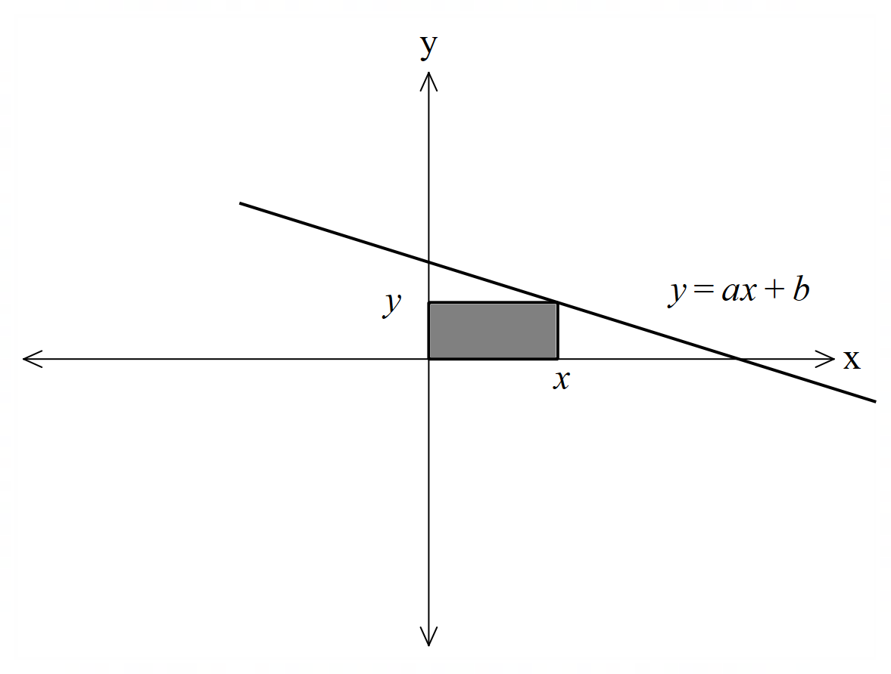

The greatest area occurs when units with an area of 32 sq units**. Using calculus**, determine the values of the constants .

|  |
| --- |
| **Solution** |
|  |
| **Specific behaviours** |
| 🗸 sets up an expression for area in terms of x  🗸 diffs and equates to zero  🗸 uses optimal x value to derive one equation for a & b  🗸 solves for a & b  Note: max of 1 mark if calculus not used |